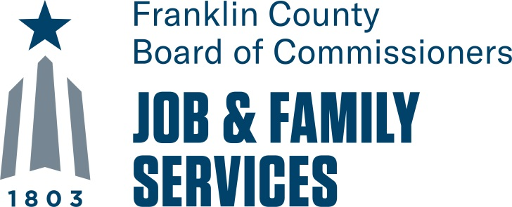

**Ohio WorkS First – Work Required Activities Management**

**25-21-RFP-01**

**required documents,**

**Attachments**

**& checklists**

**Table of Contents**

Ohio Works First – Work Required Activities Management 3

RFP Checklists 3

Ohio Works First – Work Required Activities Management 4

RFP Checklists 4

Mandatory Letter of Intent 5

Delinquent Personal Property Tax Affidavit 6

Community Portal Access Request 7

Conflict of Interest Disclosure Form 11

Narrative: 12

Sample Contract Boilerplate 18

Sample Site Agreement 28

For Reference Only 33

Ohio Works First – Work Required Activities Management

RFP Checklists: Required Documents, Attachments & Format

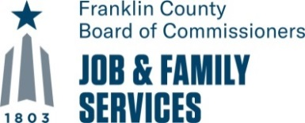

**Format:**

|  |  |
| --- | --- |
| **Emailed:** | |
|  | Mandatory Letter of Intent |
| **Entered:** | |
|  | Community Portal Access Request |
|  |  |
| **Entered directly in the RIO System:** | |
|  | a. Agency Profile |
|  | b. Board Members |
|  | b. Budget |
| **Uploaded Documents into the RIO System:** | |
|  | 1. Certificate of Professional Liability Insurance |
|  | 3. Conflict of Interest Disclosure Form |
|  | 4. Delinquent Property Tax Affidavit |
|  | 5. Employee Background Check Policy |
|  | 6. Employee Licenses (if applicable) |
|  | 7. Employee Resumes- Lead Positions |
|  | 8. Financial Audit- Most Recent |
|  | 9. Job Descriptions- All Positions |
|  | 10. Narrative |
|  | 11. Partner/Subcontractor Agreements (if applicable) |
|  | 12. Program License (if applicable) |
|  | 13. Reference Letters |
|  | 14. Resumes - for Lead Positions |
|  | 15. Table of Organization for the Agency |
|  | 16. Table of Organization for the Project |
|  | 17. Worker’s Compensation Certificate |
|  | 18. W-9 Form |

Ohio Works First – Work Required Activities Management

RFP Checklists: Required Documents, Attachments & Format

**

**Required Documents:**

|  |  |
| --- | --- |
|  | A. MANDATORY Letter of Intent (must be signed by the Organization’s Director/CEO)- due 2/12/21 |
|  | B. Community Portal Access Request (if applicable) – entered by 2/12/21 at 2:00 PM |
|  | C. Reference Letters- Three for like services provided within the last five years |
|  | D. Certificate of Good Standing - Continued Existence from the Ohio Secretary of State |
|  | E. Certificate of Professional Liability Insurance |
|  | F. Conflict of Interest Disclosure Form |
|  | G. Delinquent Personal Property Tax Affidavit (form provided by FCDJFS- must be Notarized) |
|  | H. Employee Criminal Background Check Policy |
|  | I. Financial Audit- Most Recent |
|  | J. Table of Organization for the Agency |
|  | K. W-9 Form ([www.irs.gov/pub/irs-pdf/fw9.pdf](http://www.irs.gov/pub/irs-pdf/fw9.pdf)) |
|  | L. Worker’s Compensation Certificate |
|  | M. Written Accounting System Policy & Procedures |

**Attachments:**

|  |  |
| --- | --- |
|  | 1. Narrative |
|  | 2. Job Descriptions (for all positions) |
|  | 3. Employee Licenses - for Lead Positions (if applicable)) |
|  | 4. Employee Resumes- for Lead Positions |
|  | 5. Partner/Subcontractor Agreements ((if applicable) |
|  | 6. Program Licenses/Certificates (if applicable) |
|  | 7. Table of Organization for the Project |

# Mandatory Letter of Intent

**

The **Mandatory** Letter of Intent is due to FCDJFS **by 2:00 PM** on **Friday, February 12, 2021**. The **Mandatory** Letter of Intent will authorize you to submit a proposal but does not commit the bidder to submit a proposal. The **Mandatory** Letter of Intent allows FCDJFS to effectively plan for the maximum number of proposals it will receive and need to review. Proposals will not be considered if a Mandatory Letter of Intent was not received.

**Mandatory Letter of Intent to Submit a Response to a Request for Proposals**

**You MUST Submit this Letter in Order to Submit a Proposal(s)**

**\*\*\* Please Type or Print Clearly \*\*\***

**TO**: Carmen Barnes, Deputy Director

FROM: Director/President/CEO: Phone:

(NAME)

E-mail Address:

RE: Letter of Intent for RFP Title: **Ohio Works First – Work Required Activities Management**

|  |  |
| --- | --- |
| **Name of the Organization** |  |

intends to submit a proposal in response to the Request for Proposals indicated above. Please direct all correspondence to the contact person identified below.

|  |  |  |  |
| --- | --- | --- | --- |
| Name: |  | Title: | |
| Address: |  | Apt./Ste./F.: | |
| City: |  | State: | Zip: |
| Telephone Number: |  | Fax Number: | |
| E-mail Address: | | | |
| TAX ID Number: | | | |

Submission of this form by **2:00 pm on Friday, February 12, 2021,** will ensure receipt of all notifications regarding addenda to or clarifications of this RFP. After the Bidders’ Conference, all subsequent questions and answers will be forwarded to Bidders. Failure to submit a Mandatory Letter of Intent will result in the bidder’s exclusion from this list, which will result in missing notification of significant information regarding this process. **The Mandatory Letter of Intent must be received by the established deadline in order to submit a proposal.**

|  |  |  |
| --- | --- | --- |
|  |  |  |
| Director’s Signature |  | (Date) |
|  |  |  |
| Agency Name |  | Title: |

**

# Delinquent Personal Property Tax Affidavit

This sworn affidavit should be properly completed by the authorized representative of your firm and will be incorporated as part of The Franklin County Department of Job and Family Services Purchase of Service Subaward/Vendor Agreement with .

State of Ohio:

County of Franklin, ss:

, being first duly sworn, deposes and says that he/she

(Name)

is the of (Title)

(the “Subrecipient/Vendor”) and as the Subrecipient/Vendor’s duly authorized representative states that as of

, 2021:

( ) The Subrecipient/Vendor is not charged with delinquent property taxes on the general list of personal property in Franklin County, Ohio, or any other counties containing property in the taxing districts under the jurisdiction of the Auditor of Franklin County, Ohio.

( ) The Subrecipient/Vendor is charged with delinquent personal property taxes on the general list of personal property in Franklin County, Ohio, or any other counties containing property in the taxing districts under the jurisdiction of the Auditor of Franklin County, Ohio.

County Amount:

(include total amount and any penalties and interest thereon)

Franklin $

$

$

­­­­­­­­­­­­­­­­­­­­­­­­­­­­­­­­­­­­­­­­­­­­­­­­­­­­­­­­­

(Affiant)

Sworn to and subscribed this day of , 2021.

(Notary Public)

Section 5719.042 O.R.C

(Seal) My Commission expires , 20

**

# Community Portal Access Request

Select the link below to access the Community Portal

<https://communityportal.fcdjfs.franklincountyohio.gov/>

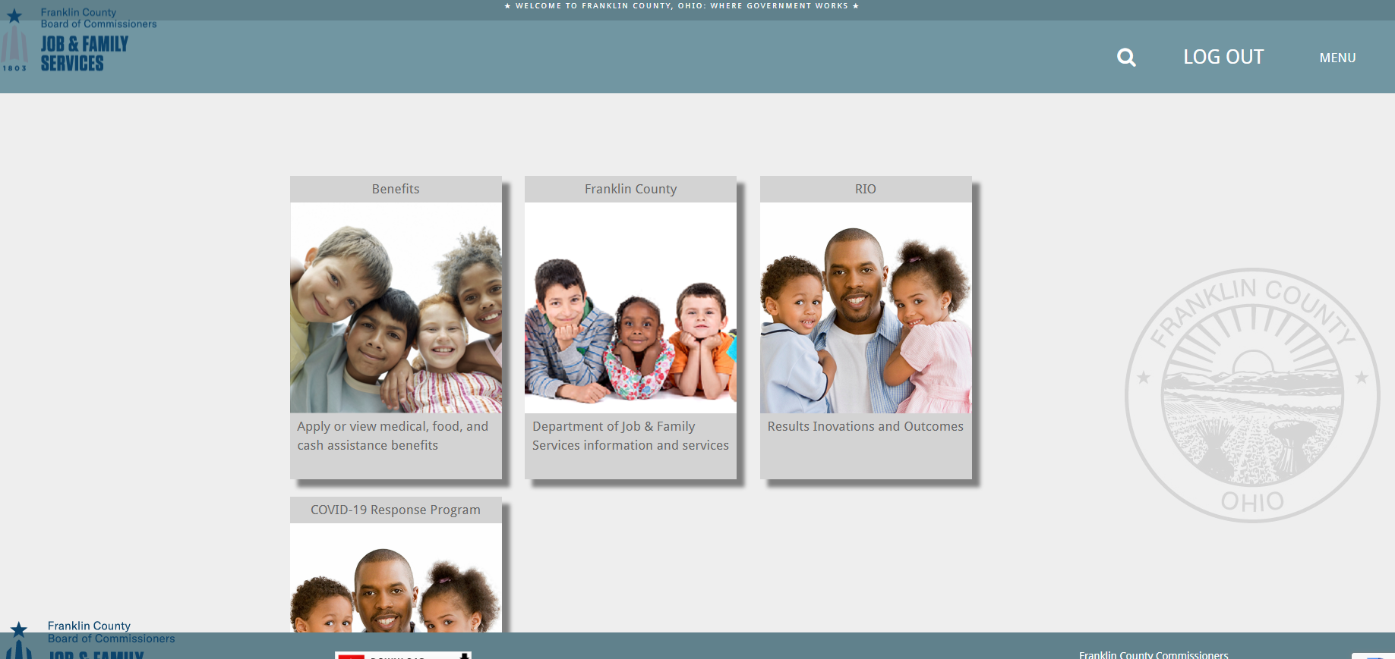

Select the option for “RIO”

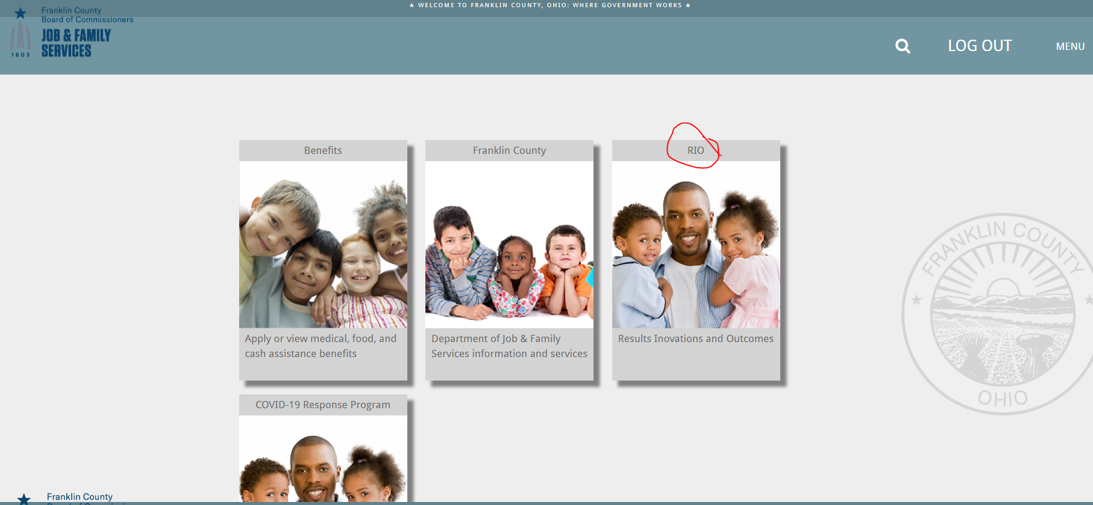

Select “Register User”

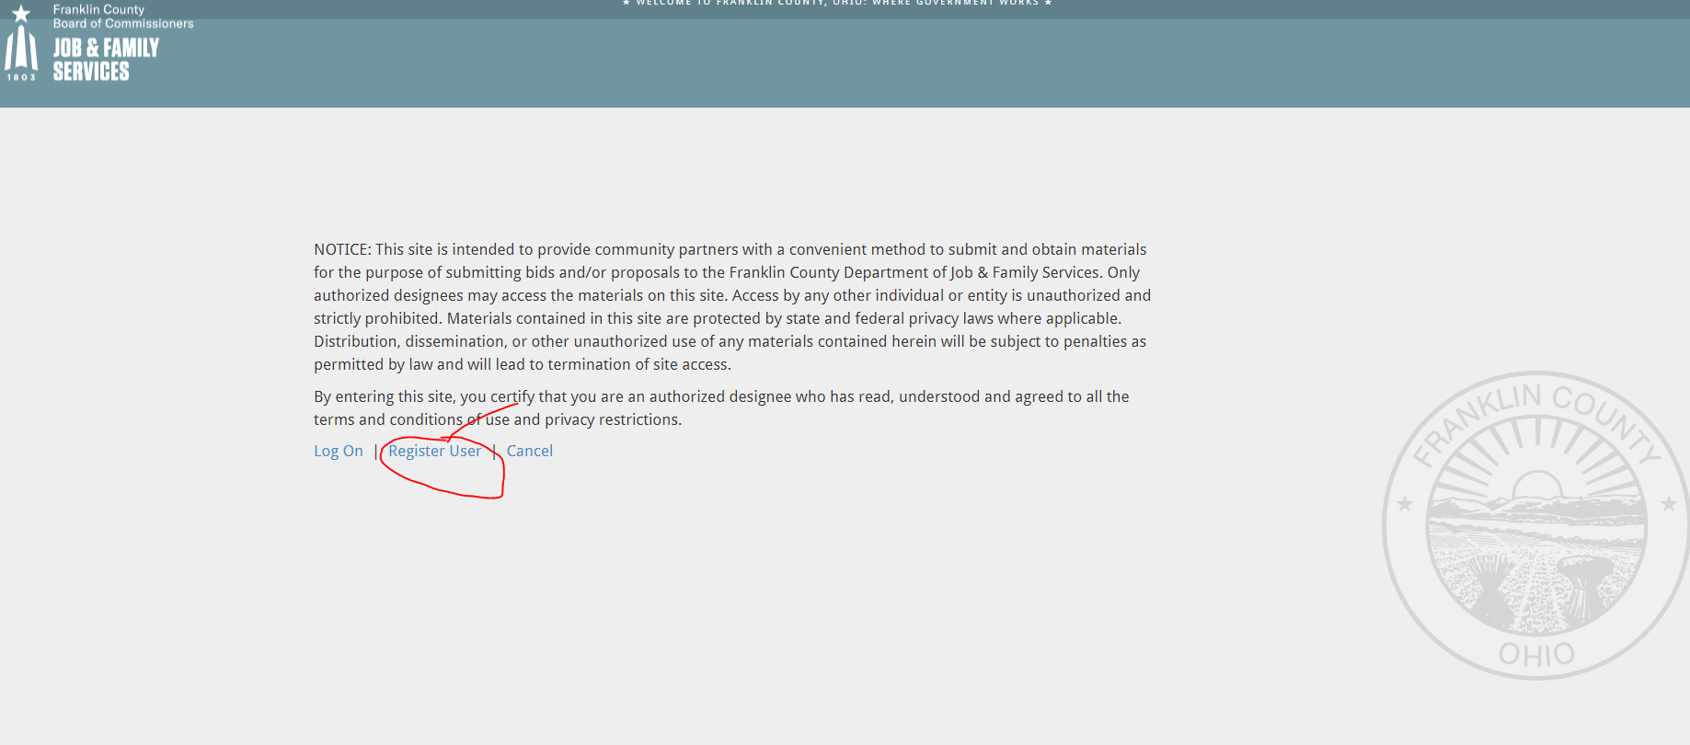

Enter the requested information.

Leave the “Agency Code” field blank.

Once you complete the required information, click “Register”.

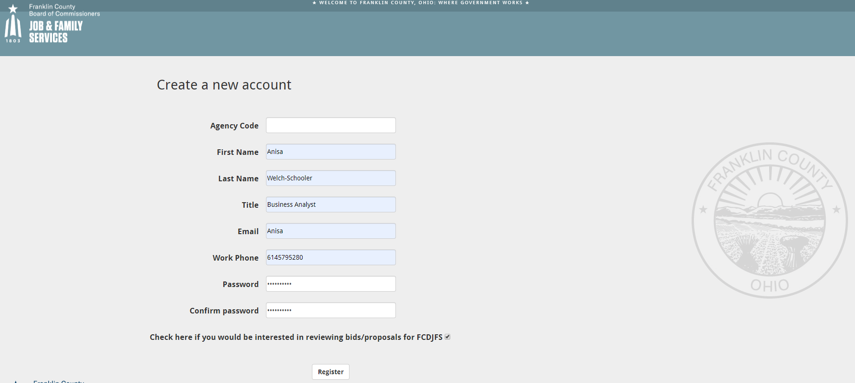

A screen will appear that states the following:

“An email has been sent to your account. Please view the email and confirm your account to complete the registration process.”

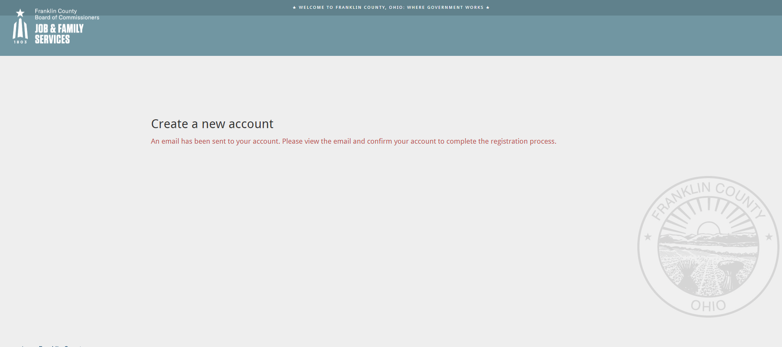

An email will be sent to the email address entered confirming your registration with a link

to the login page. Log in with the email address and password used to register.

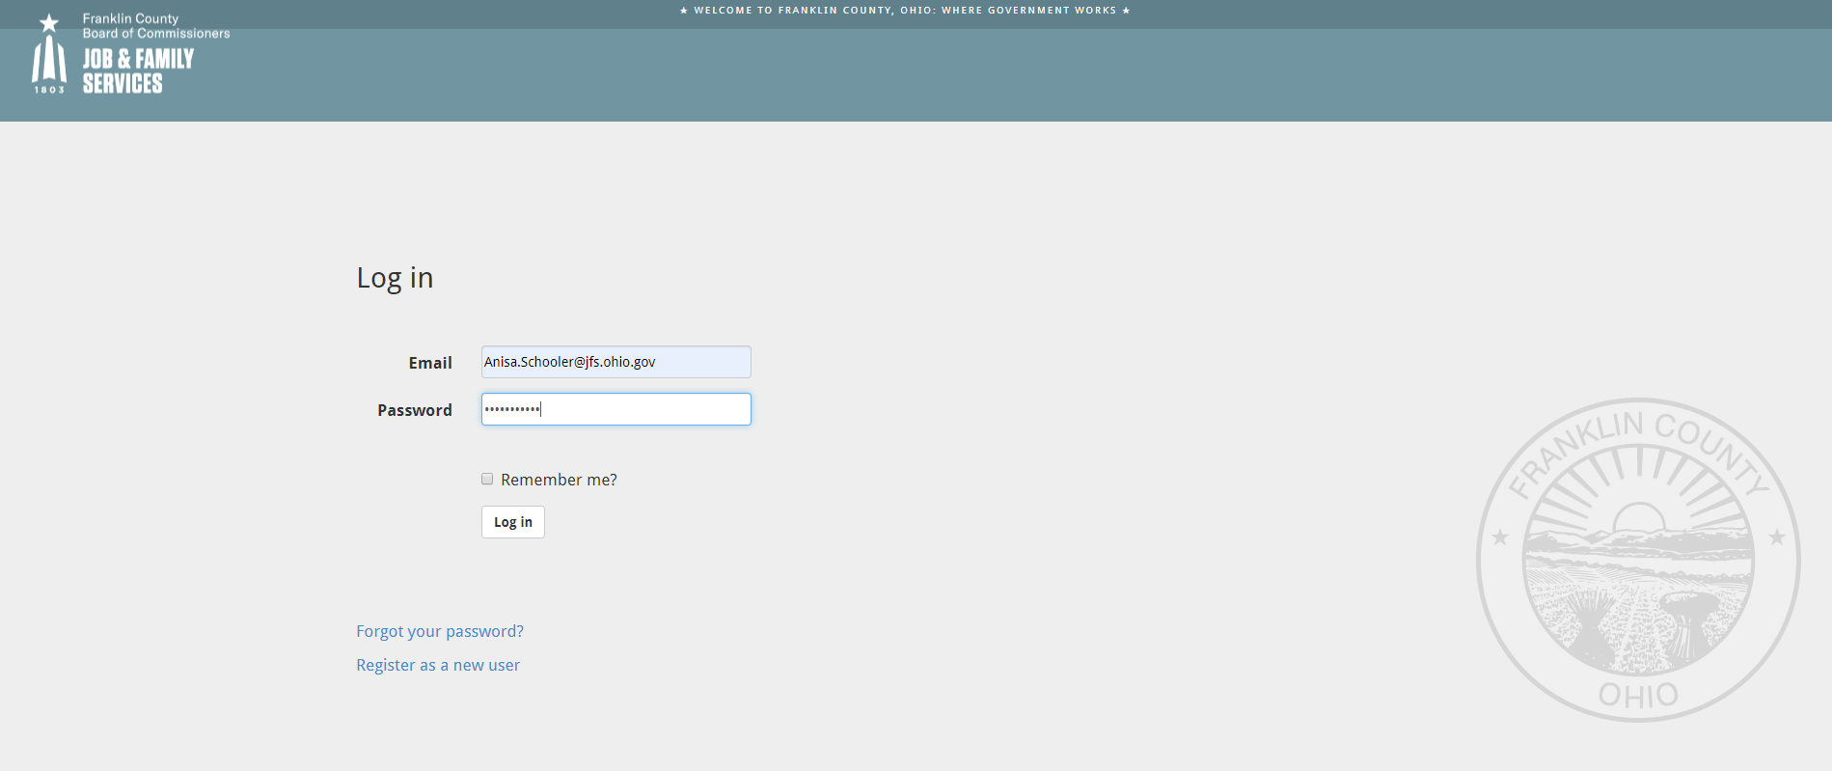

You will be asked to “Create a new agency” by entering the information requested below.

When the form is complete, click “Register”.

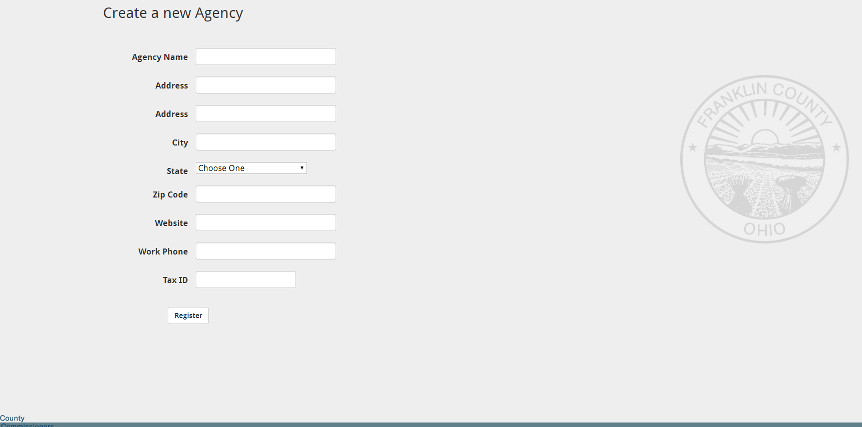

After successful agency registration, you are presented with a message that includes the new agency

ID and a link to re-log on. An email will also be sent to your address with this information.

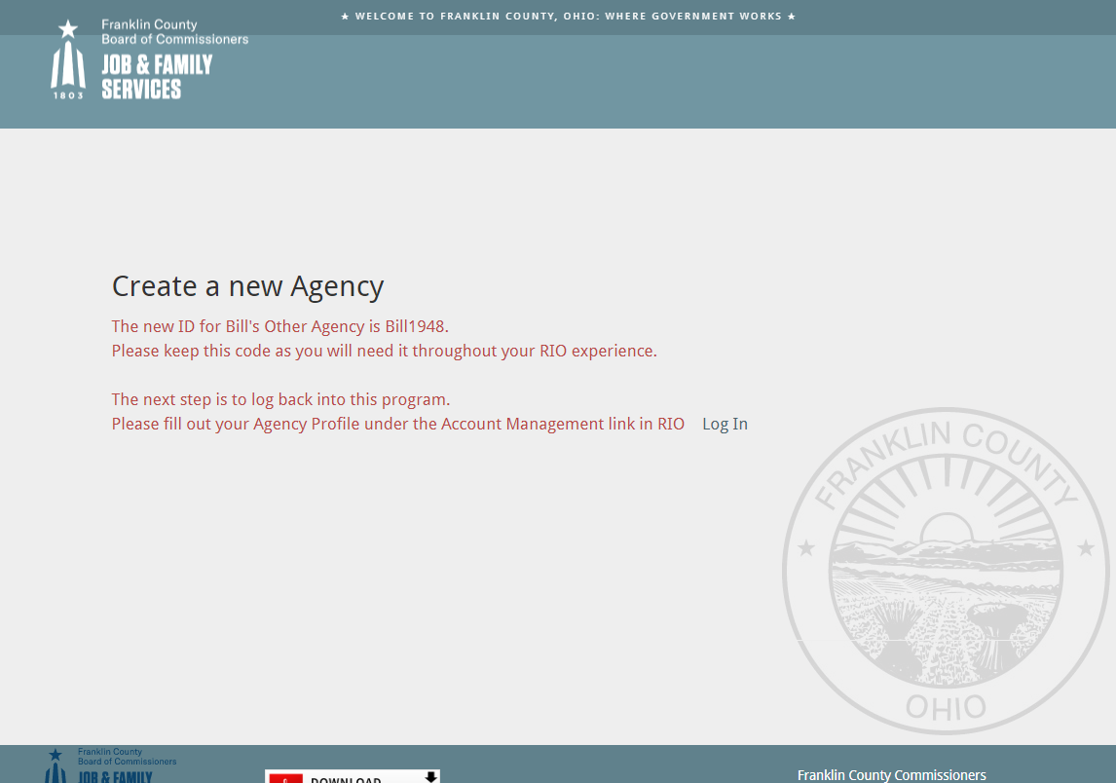

Remember to fill out your new Agency Profile and Board Member information using the Account Management link in the RIO program.

# Conflict of Interest Disclosure Form

**

Name:

Company:

Position in company:

Please describe below any and all relationships and/or connections you have to any FCDJFS employee(s) that could contribute or could be viewed as potentially contributing, to a conflict of interest:

I have no conflict of interest or potential conflict of interest, to report

I have the following conflict of interest or potential conflict of interest, to report

(Please identify the individual[s] with whom you have, or may have, a personal,

familial, or business relationship, or to whom you are otherwise connected):

1.

2.

3.

I hereby certify that the information set forth above is true and complete to the best of my knowledge, and that I have reviewed, and agree to abide by, the Conflict of Interest and Ethics Compliance Certification and Disclosure provisions contained in the RFP.

|  |  |  |
| --- | --- | --- |
| (Signature) |  | (Date) |

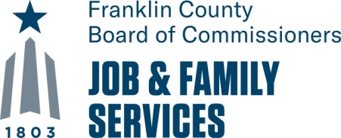

# Narrative:

**Ohio Works First**

**Work Required Activities Management**

|  |  |
| --- | --- |
| **Agency Name:** |  |

***Directions:******Please keep answers concise****.*

|  |
| --- |
| **OWF – WORK ACTIVITIES MANAGEMENT**  **PROPOSAL NARRATIVE** |
| 1. Provide a brief description/history of your organization. Include the mission statement, vision statement, and strategic goals and/or initiatives. Describe the organization’s structure as it relates to the provision of workforce services. |
| Click or tap here to enter text. |
| 1. Describe the organization’s experience and ability to successfully manage similar size and scope projects. Include, but do not limit your response to, the scope of work; quality of work; timeliness and cost effectiveness of services; and challenges, lessons learned, and successes. Your response must demonstrate that you have at least 3 years’ experience managing work activities and workforce services for OWF participants similar in the size and scope of this project. |
| Click or tap here to enter text. |
| 1. Describe how your organization will provide the scope of services detailed in the RFP to the projected number of OWF work required participants in accordance with all programmatic rules and requirements of FCDJFS. This response must include but is not limited to the following:    1. Provide a detailed description of the services to be provided including, but not limited to, information related to curricula used, schedule of service, outputs, and outcomes of services |
| Click or tap here to enter text. |
| * 1. Provide a detailed description of the service delivery model inclusive of how a participant is expected to move through the services. The response should include plans to provide services virtually in accordance with current health and safety standards. |
| Click or tap here to enter text. |
| * 1. Provide a detailed description of the specific, measurable, and relevant goals and outcomes |
| Click or tap here to enter text. |
| * 1. Provide a detailed description of the recruitment, development, and management plans for work experience, community service, SEP, and OJT sites as detailed in the RFP. The bidder must demonstrate the capacity to manage this work as evidenced by existing partnerships and relationships with local service providers, public and private business sectors, and other relevant local entities and community organizations (FCDJFS expects 60% of the work activity sites to reflect local in-demand industries). |
| Click or tap here to enter text. |
| * 1. Provide a detailed description of established and proposed subcontracted partners, their roles and responsibilities, and payment structure |
| Click or tap here to enter text. |
| * 1. Provide a detailed description of how the organization will develop and manage business relationships and successfully conduct employment placement and retention services in accordance with the RFP |
| Click or tap here to enter text. |
| * 1. Provide a detailed description of the case management and supportive services the organization will provide in accordance with the RFP. This should include, but not be limited to the electronic system that will be used and its functionality, a description of the data that will be collected, how the staff will utilize the system to track participant assessments, case plans, service needs, and services utilized, and how the information will be transmitted to FCDJFS |
| Click or tap here to enter text. |

|  |
| --- |
| * 1. Provide a detailed description of how the organization addresses barrier removal. Include examples and data to support the type of barriers and successes achieved over the last three years. Please include innovative strategies to address transportation barriers. |
| Click or tap here to enter text. |
| 1. Describe the organizational capacity to manage the size and scope of the services identified in the RFP. This response must include staffing and management structures or plans, and a project timeline.  * Staffing plan must detail the staffing structure, roles and responsibilities, and qualification of the bidder’s staff as well as the staff requirements and structure of any subcontracted partners. This should include education, career history, workforce development competencies and experience, staff position descriptions, and resumes; * Management Plan must demonstrate the overall structure of the proposed service delivery model and how that structure will be sufficiently managed. This should be inclusive of all established and proposed subcontracted relationships; and * Project timeline should include but not be limited to hiring and training, services schedules, reporting timelines, and other major activities related to the operation of these services. |
| Click or tap here to enter text. |
| 1. Describe the technology infrastructure and capacity to manage the project and all requisite data as evidenced by electronic case management, timekeeping, and reporting system.   **a.** Describe in detail:   * the system(s) to be used; * how the system(s) are managed and secured; * how will participants, worksites, and staff will access and use the system; * how will information/data be shared or transmitted to FCDJFS; and * how will your organization assure that data is captured and is available for review and reporting in real-time |
| Click or tap here to enter text. |
| * + 1. Describe your organization’s data back-up processes and disaster recovery plan. |
|  |
| 1. Describe your organization’s fiscal and administrative management systems. Inclusive of an accounting system with adequate financial controls; adequacy of approved cost allocation plan; audits and fiscal monitoring reports free of findings; historically accurate and timely financial and programmatic information. |
| Click or tap here to enter text. |
| 1. Provide a detailed description of how your organization will provide services that are culturally and linguistically appropriate. Bidders must provide meaningful access to services to all eligible participants. The ODJFS Office on Civil Rights defines meaningful access as the ability to use services and benefits comparable to those enjoyed by members of the mainstream cultures. It is achieved by eliminating communication barriers and ensuring that the client or potential client can communicate effectively. An organization must ensure that the LEP (Limited English Proficient) person:    * + Is given adequate information      + Is able to understand the services and benefits available      + Is able to receive services for which he or she is eligible      + Can effectively communicate the relevant circumstances of his or her situation to the service provider; and      + Receives language assistance at no cost |
| Click or tap here to enter text. |
| 1. Provide any additional information, not already provided, that your organization deems is pertinent for FCDJFS to review in consideration of this proposal. |
| Click or tap here to enter text. |

|  |
| --- |
| Sample Contract Boilerplate |

Bidders chosen to provide services under this RFP for FCDJFS will need to adhere to the terms outlined in the Subaward Agreement Boilerplate. The boilerplate will delineate the units of service, unit costs, and total subaward agreement amount for the program. Boilerplate is subject to change.

**Contract # 25-20-xxxx**

**CFDA:**

**FAIN #:**

**Federal Agency:**

**Award Name:**

**THE FRANKLIN COUNTY DEPARTMENT OF JOB AND FAMILY SERVICES**

**PURCHASE OF SERVICE CONTRACT WITH**

**CONTRACTOR**

This contract is made and entered into enter Commissioner’s Agenda date, by and between the Board of Commissioners of Franklin County, Ohio, on behalf of the Franklin County Department of Job and Family Services (FCDJFS) and Contractor Name doing business at address, Columbus, Ohio 43215 (hereinafter referred to as "Contractor").

Background Information

A. Pursuant to the Ohio Administrative Code (OAC) and rules promulgated by the Ohio Department of Job and Family Services (FCDJFS), the Franklin County Department of Job and Family Services (FCDJFS) is authorized to contract with public and private organizations for the purchase of XX services.

B. FCDJFS desires to enter into this Purchase of Service Contract with the Contractor in order to assist FCDJFS with ending the dependence of needy parents on government benefits by promoting job preparation, work, and marriage, upon the terms and conditions of this Contract.

**Scope of Work:** insert a very brief description of the services to be provided and outcomes expected.

Provisions.

**ARTICLE I: TIME, DELIVERABLES, COMPENSATION, AND REPORTING**

**A. PURCHASE OF SERVICE:** Subject to terms and conditions set forth in this Contract, including the appendices outlined in Article V Section M below, which are on file at FCDJFS and available for review by the Contractor, the Contractor agrees to furnish those specific services detailed in this Contract.

**B. CONTRACT PERIOD:** This contract will be effective from date, 2021 through date, 2022 inclusive unless otherwise terminated. The contract period may be extended for up to 24 months upon these terms by mutual consent of the parties and contingent upon the availability of funding.

**C. AVAILABILITY OF FUNDS:** Payments for all services provided in accordance with the provisions of this Contract are contingent upon the availability of federal, state, and local program funds.

**D. COST AND DELIVERY OF PURCHASED SERVICES:** Subject to the limitations specified in Article I-D hereof and as detailed in Appendices A (Clarification of Contract Terms), on file at FCDJFS, the amount to be paid for such purchased services shall be by a fixed unit rate, based on the following allowable units of service (the “Purchased Services’):

|  |  |  |  |
| --- | --- | --- | --- |
| **Services to be provided from (start Date) through (end date)** | | | |
| **UNIT OF SERVICE** | **UNIT COST** | **UNITS UNDER CONTRACT** | **TOTAL COST** |
|  |  |  |  |
| **Total Value of Contract** | | |  |

**E. PURCHASED UNITS OF SERVICE:** It is the responsibility of the Contractor to monitor the expenses authorized by FCDJFS in accordance with the provisions of Section D above. Should the Contractor incur expenses in excess of what was authorized by this Contract, the Contractor shall be responsible for the expense(s) incurred.

The CONTRACTOR expressly understands that FCDJFS will not compensate the CONTRACTOR for any work performed prior to notification from FCDJFS, and the Contractor expressly understands that FCDJFS shall not compensate the CONTRACTOR for any work performed after the termination date set forth in this Contract or in the event this Contract is terminated pursuant ARTICLE III-E, *Termination and Suspension.*

**F. ELIGIBILITY:** When applicable, the eligibility of individuals to receive services will be determined in accordance with the policies and procedures established by the Franklin County Department of Job and Family Services. The Contractor shall provide service only for those individuals determined eligible by FCDJFS, using the income guideline of 200% of the federal poverty level. As a result of the eligibility determination, the Contractor shall issue the appropriate approval or denial notice, whichever is applicable, to the applicant within thirty (30) days of application for services. A copy of the approval or denial notice shall be maintained in the participant file along with the TANF Registration Form and documents verifying eligibility.

The FCDJFS shall be the final authority in determining which consumers will be served under the terms of this contract as specified in this Article F, *Eligibility*.

**G. INVOICING:** The Contractor shall bill submit monthly invoices in the manner defined by FCDJFS, on the template provided by FCDJFS. The invoice shall be received by FCDJFS no later than fifteen (15) calendar days following the month of service. The Contractor will use the invoice template provided by FCDJFS. The invoice summary will show the date of the invoice and the period for which the services billed were rendered. Invoices may be submitted only for actual services provided during the effective dates of the contract, not to exceed the number of units authorized by FCDJFS, and must reflect the approved fixed unit cost for each unit of service. The Contractor must certify that claims made to FCDJFS for payment of purchased services are for actual services rendered to eligible individuals, if applicable, and are for the completion of contracted measures/standards. The Contractor must maintain documentation of all expenses, which must be made available upon request by FCDJFS and will be verified during the Contractor monitoring.

FCDJFS shall review the submitted invoice for completeness and accuracy before making payment within forty-five (45)days after approval, contingent upon the availability of federal, state, and local program funds. The expenditures reported on the invoice are subject to review by FCDJFS before payment is made. The Contractor hereby authorizes FCDJFS to adjust for mathematical errors, incorrect unit rates, or non-covered services and agrees that FCDJFS shall not reimburse the Contractor for services that do not have prior authorization, exceed the authorization, or exceed the maximum dollar amount of the contract.

FCDJFS does not have the ability to compensate the CONTRACTOR for work performed under the Contract after the purchase order for the Contract has been closed. The final invoice for compensation of work performed under this Contract must be received by FCDJFS no later than thirty (30) days after the termination date of this Contract. Failure of the CONTRACTOR to submit the final invoice by this deadline will be deemed forfeiture and waiver by the CONTRACTOR for any claims for all remaining compensation due hereunder.

**H. DUPLICATE INVOICING:**  The Contractor certifies that any costs incurred under this Contract shall not be chargeable to or included as a cost in any other federally financed program in either the current or a prior period. Further, the Contractor warrants that claims made to FCDJFS for payment of Purchased Services under this Contract shall be for actual expenses for the employee(s) hired under this Contractand do not duplicate claims made by the Contractor to other sources of funds for the same service.

**I. REPORTING:** The Contractor will provide monthly reports to FCDJFS regarding Purchased Services on the schedule, template and in the manner specified by FCDJFS. Reporting may be required via electronic media.

**J. ANNUAL RECONCILIATION:** A reconciliation will be completed by FCDJFS no later than sixty (60) days following the end of the contract period.

**K. PUBLICITY:** In any publicity release or other public references including media releases, information pamphlets, etc., regarding the services provided under this Contract, it will be clearly stated that the services are funded by the Franklin County Board of Commissioners and administered by FCDJFS.

**ARTICLE II: PROCUREMENT, SUBCONTRACTING COMPLIANCE, AND AUDIT RESPONSIBILITIES**

**A. PROCUREMENT REQUIREMENTS:** The procurement requirements for contracts are found in the Ohio Administrative Code (OAC) 5101:9-04-02 (Standards of Acquisition); OAC 5101:9-4-07 (Procurement Requirements) and OAC 5101:9-1-88 (Subrecipient Annual Risk Assessment Review and Monitoring Process) and Ohio Revised Code 307.86 (Competitive Bidding Required –exceptions). In order to subcontract or enter into a secondary contract agreement for services, the Contractor is also subject to the procurement requirements outlined in the foregoing regulatory provisions.

**B. EXECUTION OF SUBCONTRACTS**: In the event the Contractor determines to deliver some of the Purchased Services through a subcontractor, the Contractor agrees that each subcontract shall be properly procured in accordance with the standards listed in ARTICLE II-A *Procurement Requirements* orthe Contractor’s procurement requirements, whichever is the most restrictive. All subcontracts shall be subject to the same terms, conditions and covenants contained in this Contract and shall allow FCDJFS to pursue direct claims against the subcontractor. The Contractor is required to secure the following documentation which verifies that the subcontractor is in no way excluded from receiving state, local, federal funds: (a) The System of Award Management (located at <https://www.sam.gov/>portal/public/SAM), (b) The Auditor of the State of Ohio Findings for Recovery Database is located at <http://www.auditor.state.oh.us/resources/findings/certified/default.aspx>.

All subcontracts shall explicitly state the description of services, rate of pay, subcontract amount, subcontract period, and any other descriptive information regarding the services to be provided consistent with the provisions of this Contract. All subcontracted costs shall be accounted for in the Contractor’s budget as professional fees or subcontracted services. The Contractor is responsible for making direct payment for such services to the subcontractor and shall expressly state that in not event shall the County or FCDJFS be responsible for any such payments. Notwithstanding the foregoing, the Contractor agrees that it shall not make any payment on subcontracted services without first having filed the signed subcontract with FCDJFS. No subcontracts shall in any case relieve the Contractor of any duty, obligation, or liability undertaken by the Contractor pursuant to this Contract.

**C. INDEPENDENT CONTRACTORS:** Contractor will act in performance of this Contract in an independent capacity, and not as officers, employees, or agents of the Ohio Department of Job and Family Services, the County, or FCDJFS.

**D. RESPONSIBILITY FOR AUDIT:** The Contractor shall maintain all books, records, payroll, documents, accounting procedures, and practices which sufficiently and properly reflect all expenses and administrative costs of any nature incurred in the performance of this Contract. Such records shall be made available at all reasonable times during regular business hours for inspection, review, or audit by duly authorized Federal, State, County, and FCDJFS personnel. Such records shall also be subject to inspection by the individual or entity selected for the audit required by this contract agreement.

The Contractor agrees to, if required by the director of FCDJFS because of a suspicion of misuse or improper accounting of funds for which the Contractor is responsible, have conducted an independent audit of expenditures and make copies of the audit available to FCDJFS.

The Contractor shall make available to FCDJFS all other audit reports upon request.

**E. RESPONSIBILITY FOR AUDIT EXCEPTIONS:** The Contractor agrees to accept responsibility for receiving, replying to, and/or complying with any audit exception by appropriate county, state, or federal audit directly related to the provisions of the contract, or subcontract. The Contractor agrees to pay FCDJFS for all amounts due as a result of audit exceptions.

The Contractor agrees to pay to FCDJFS the full amount of the payment received on behalf of individuals for whom eligibility has not been established in accordance with policies and procedures established by the Franklin County Department of Job and Family Services, if applicable.

The Contractor agrees to pay to FCDJFS the full amount of payment received for services not covered by the contract.

The Contractor agrees to pay to FCDJFS the full amount of payment received for duplicate billing, erroneous billing, deceptive claims, or falsification.

As used in this section “deceptive” means knowingly deceiving another or causing another to be deceived by a fake or misleading representation, by withholding information, by preventing another from acquiring information, or by any other act, conduct, or omission which creates, confirms, or perpetuates a fake impression in another, including a fake impression as to law, value, state of mind, or other objective or subjective fact.

The Contractor is responsible and agrees to pay for any audit exception by appropriate county, state, or federal audit identified within a subcontract as defined in Article II-B, *Execution of Subcontracts*

Any payments due under the provisions of this section shall be paid by the Contractor within 90 days of demand for payment by FCDJFS,

**F. RETENTION OF RECORDS:** The Contractor shall maintain and preserve all records related to this contract. This includes any documentation used in the administration of the program. Records must be maintained for a period of seven years from the termination date of this Contract or the closure of an outstanding audit. The Contractor will assure the maintenance of such records for a like period of time in the possession of any third party performing work related to this contract, unless otherwise directed by FCDJFS.

If any litigation, claim, negotiation, audit, or other action involving the records has been started before the expiration of the seven year period, the Contractor shall retain the records until completion of the action and all issues which arise from it or until the end of the seven year period, whichever is later.

**ARTICLE III: NOTICES, AMENDMENTS, BREACH, SUSPENSIONS, AND TERMINATIONS**

**A. NOTIFICATION OF SIGNIFICANT DEVELOPMENTS:** The Contractor shall immediately notify FCDJFS in writing of developments that have a significant impact on the Purchased Services to be provided under this Contract or the performance of any other material obligation under this Contract. Written notification shall be given in the case of problems, delays, or adverse conditions which materially impair the Contractor’s ability to meet the objectives of the Contract. The notification must include a statement of the action taken or the proposed course of action. FCDJFS will provide technical assistance and approval of any significant change and will amend the contract as it deems necessary and appropriate in its sole and absolute discretion.

**B. NOTICE:** Notice given by one party to the other hereunder shall be in writing and deemed to have been properly given or paid if deposited with the United States Postal Service via registered or certified mail and addressed as follows:

|  |  |
| --- | --- |
| Contractor Agency | Franklin County Department of Job and Family Services |
| Contractor Agency Director |  |
| Contractor Agency Street Address |  |
| Contractor Agency Street Address Line 2 |  |
| Contractor Agency City, State Zip Code  Contractor Telephone #  Contractor Email |  |
|  |  |

**C. AMENDMENT OF CONTRACT:** This contract may be amended at any time by a written amendment mutually agreed to and signed by all parties in the manner required by state regulations. The Contractor will be required to submit a revised budget supporting the changes made in the amendment, unless FCDJFS grants a written exception.

**D. DELEGATION OF AUTHORITY:** Pursuant to authority assigned by the Franklin County Board of Commissioners under Ohio Revised Code 329.04, the Director of the Franklin County Department of Job and Family Services has the power to directly consent to and execute extensions and renewals of the contract period for up to one year under Article I-B, *Contract Period*, execute amendments under Article III-C, *Amendment of Contract*, and terminate the contract under Article III-E, *Termination and Suspension* This power is limited as follows:

The cost for the new contract period under any contract extension or renewal may be less than but not greater than the original/underlying contract on a prorated basis. The power to amend is limited to increasing or decreasing the unit cost and the number of units under contract (as set forth in Article I-D, *Cost and Delivery of Purchased Services),* with the restriction that costs remain equal to or less than the total original/underlying costs on a prorated basis. All other terms and conditions are to remain the same.

**E. TERMINATION AND SUSPENSION:** Notwithstanding other provisions in this ARTICLE III, either party may terminate this Contract at will by giving thirty (30) days written notice to the other party. Upon thirty (30) days written notice to the CONTRACTOR, FCDJFS may suspend this Contract at FCDJFS’s sole discretion.

Notwithstanding this ARTICLE III, *Notices, Amendments, Breach, Suspensions, and Terminations,* FCDJFS may suspend or terminate this Contract immediately upon delivery of written notice to the CONTRACTOR if FCDJFS has discovered any illegal conduct on the part of the CONTRACTOR, any violation ARTICLE V: *Certifications and Assurances Made by the CONTRACTOR*, loss of funding as set forth in ARTICLE I-C *Availability of Funds*, or the filing of a petition in bankruptcy (or similar proceeding) by or against the CONTRACTOR.

The CONTRACTOR, upon receipt of notice of suspension or termination, agrees to cease work on the suspended or terminated activities under this Contract, to suspend or terminate all subcontracts relating to such suspended or terminated activities, to take all necessary and/or appropriate steps to limit disbursements and minimize cost, and to furnish a report as of the date notice of suspension or termination was received, that describes the status of all work under this Contract that includes, without limitation, the Deliverables completed, the outcomes of the completed Deliverables, and any other information that FCDJFS may require. Suspension, termination, or expiration of this Contract shall not limit the CONTRACTOR’s continuing obligations with respect to Deliverables paid for by FCDJFS prior to the suspension or termination nor will it limit FCDJFS’s rights in those Deliverables.

In the event of suspension or termination under this ARTICLE III, *Notices, Amendments, Breach, Suspensions, and Terminations,* the CONTRACTOR will be entitled to compensation, upon submission of a proper invoice per ARTICLE I-G, *Invoicing*, for the work performed prior to the CONTRACTOR’s receipt of notice of suspension or termination. Compensation will be calculated by FCDJFS based on the compensation structure set forth in ARTICLE I-D, *Cost and Delivery of Purchased Services*, less any funds previously paid by or on behalf of FCDJFS, or in the case of services for which CONTRACTOR charges a flat rate, based on a reasonable percentage of the total services performed as determined by FCDJFS, less any funds previously paid by or on behalf of FCDJFS.

**F. CURE OF BREACH:** Except as otherwise provided in Section E, *Termination and Suspension* of this ARTICLE III the CONTRACTOR will have thirty (30) calendar days within which to cure any breach that is curable after receipt of written notice from FCDJFS that CONTRACTOR is in breach of any of its obligations under this Contract and such proposed course of action is acceptable to FCDJFS. If the CONTRACTOR fails to cure the breach within the thirty (30) calendar days or if the breach is not curable, FCDJFS may immediately suspend or terminate this Contract. FCDJFS may also suspend or terminate this Contract if the breaches by the Contractor are persistent, regardless of whether they are cured within thirty (30) calendar days. For purposes of this Section F, “persistent” means that FCDJFS has notified the CONTRACTOR three (3) times in writing of the CONTRACTOR’s failure to meet any of its contractual obligations. The three (3) notices do not have to relate to the same obligation or type of failure. After the third notice, FCDJFS may suspend or terminate this Contract without a cure period if the CONTRACTOR again fails to meet any contractual obligation. At the sole discretion of FCDJFS, certain instances of breach may require a shorter cure period than the thirty (30) calendar days generally applicable in this Section F. In such instances, FCDJFS will include in its notice of breach the shorter cure period deemed appropriate.

Upon breach or default of any of the provisions, obligations, or duties embodied in this Contract, FCDJFS may exercise any administrative, contractual, equitable, or legal remedies available, without limitation. The waiver of any occurrence of breach or default is not a waiver of subsequent occurrences, and FCDJFS retains the right to exercise all remedies hereinabove mentioned.

**G. WAIVER OF OBIGATIONS:** If FCDJFS or the CONTRACTOR fails to perform an obligation or obligations under this Contract and the failure is thereafter waived by the other party, FCDJFS and the CONTRACTOR understand that the waiver is limited to that particular occurrence of failure and will not be deemed a waiver of subsequent failures

**ARTICLE IV: EQUAL EMPLOYMENT OPPORTUNITY, EQUAL TREATMENT, CIVIL RIGHTS AND LEGAL COMPLIANCE**



**A. EQUAL EMPLOYMENT OPPORTUNITY*:*** In carrying out this Contract, the CONTRACTOR agrees not to discriminate against any employee or applicant for employment because of race, religion, national origin, ancestry, color, gender, gender identity, sexual orientation, age, disability, or veteran status. The CONTRACTOR will ensure that applicants are hired and that employees are treated during employment in matters of employment, upgrading, demotion, or transfer; recruitment or recruitment advertising; layoff or termination; rates of pay or other forms of compensation; and selection for training including apprenticeship, without regard to their race, religion, national origin, ancestry, color, gender, gender identity, sexual orientation, age, disability, or veteran status. The CONTRACTOR certifies current and ongoing compliance with the Executive Order 11246 concerning Equal Employment Opportunity, as amended by Executive Order 11375, and as supplemented by Department of Labor regulations found at 41 Code of Federal Regulations (CFR) 60.

The CONTRACTOR further agrees that it shall include a similar provision in any subcontract, secondary contract agreement, or award issued by that entity for the performance of duties related to such subcontract, secondary contract agreement, award, or procedure.

**B. EQUAL TREATMENT:** Pursuant to Section 45 CFR 87.1 and 45 CFR 87.2, the Contractor warrants and agrees to the following: The Contractor agrees to comply with the requirements governing “Equal Treatment for Faith Based Organizations”.  The Equal Treatment Regulation provides in part that direct funding may not be used to fund any inherently religious activities, such as worship, religious instruction, or proselytization.  Recipients of direct funding may still engage in inherently religious activities, but such activities must be separate in time o

r place from the funded program, and participation in such activities by individuals receiving services from the Contractor, subcontractor, or secondary Contractor must be voluntary.  The Equal Treatment Regulation also makes clear that organizations participating in programs are not permitted to discriminate in the provision of services on the basis of a beneficiary’s religion.

**C. CIVIL RIGHTS:** The FCDJFS and the Contractor agree that as a condition of this contract, there shall be no discrimination against any eligible individual or any employee because of race, color, sex, religion, national origin, handicap, or any other factor as specified in Title VI of the Civil Rights Act of 1964, Rehabilitation Act of 1973, and subsequent amendments. It is further agreed that the Contractor will comply with all appropriate federal and state laws regarding such discrimination, and the right to and method of appeal will be made available to all persons under this contract.

**D. LEGAL COMPLIANCE:** Pursuant to Section 125.111 of the Ohio Revised Code, the Contractor warrants and agrees to the following: (1) That in the hiring of employees for the performance of work under the contract or any subcontracts or secondary contracts, the Contractor shall not by reasons of race, color, religion, sex, age, disability, national origin, or ancestry, discriminate against any citizen of this state in the employment of a person qualified to perform the work in which the contract agreement relates; and (2)That neither the Contractor nor any of its subcontractors, or any person acting on behalf of the Contractor shall in any manner discriminate against, intimidate, or retaliate against any employee hired for the performance of work under the contract agreement on account of race, color, religion, sex, age, disability, national origin, or ancestry.

The CONTRACTOR agrees to post in conspicuous places, available to all employees and applicants for employment, notices stating that the CONTRACTOR complies with all applicable federal and state nondiscrimination laws. The CONTRACTOR will incorporate the foregoing requirements of this ARTICLE IV, *Equal Employment Opportunity, Equal Treatment, Civil Rights, and Legal Compliance* in all solicitations or advertisements for employees placed by or on behalf of the CONTRACTOR and in all of its contracts for any of the work prescribed in this Contract. The CONTRACTOR will also require all of its Subcontractor to incorporate such requirements in all subcontracts for any part of the work under this Contract.

**E. AMERICANS WITH DISABILITIES ACT:** The CONTRACTOR, its officers, employees, members, and subcontracts hereby certify current and ongoing compliance with the statutes and regulations pertaining to The Americans with Disabilities Act of 1990 and Section 504 of the Rehabilitation Act of 1973.



**F. FEDERAL PRE-EMPTION:** Except when pre-empted by Federal statute and/or federal award guidelines, the Contractor shall not, by reason of race, color, religion, sex, age, disability, national origin, or ancestry, discriminate against any citizen of this state with regard to provision of services.

**G. INDEMNITY AND INSURANCE:** if the Contractor is not a political subdivision of the State of Ohio then the Contractor agrees to:

INDEMNITY: The Contractor agrees that it shall at all times during the existence of this Contract indemnify and save harmless the FCDJFS, the Ohio Department of Job and Family Services, and the Franklin County Board of Commissioners against any and all liability, loss, damage, and/or related expenses incurred through the provision of services under this contract.

INSURANCE: The Contractor agrees to contract for such insurance as is reasonably necessary to adequately secure the persons and estates of eligible individuals against reasonable foreseeable torts which would cause injury or death.

Section G shall apply unless specifically waived in writing by FCDJFS.

**H. GOVERNING LAW:** This contract and any claims arising in any way out of this Contract shall be governed by the laws of the State of Ohio. Any litigation arising out of or relating in any way to this contract or the performance hereunder shall be brought only in an Ohio court of competent jurisdiction in Franklin County, Ohio, and the Contractor hereby irrevocably consents to such jurisdiction.

**ARTICLE V: CERTIFICATIONS AND ASSURANCES MADE BY CONTRACTOR**

By executing this Contract, the CONTRACTOR certifies recurrent and continued compliance with each condition listed in this ARTICLE V***,*** *Certifications and Assurance Made by Contractor.* The CONTRACTOR’s certification of compliance with each of these conditions is considered material representations of fact upon which FCDJFS relied upon in entering into this Contract.

The CONTRACTOR certifies that all approvals, licenses, or other qualifications necessary to conduct business in Ohio have been obtained and are current. If at any time during the contract period the CONTRACTOR becomes disqualified from conducting business in Ohio for any reason, the CONTRACTOR must immediately notify FCDJFS of the disqualification, and immediately cease performance hereunder.

If any of the information pertaining to ARTICLE V, Sections A-L changes after the Contract has been signed, the CONTRACTOR agrees to report such changes immediately to FCDJFS in writing to the address listed for notice in ARTICLE III-B, *Notices*.

If at any time the CONTRACTOR is not in compliance with the conditions certified and affirmed in this ARTICLE V, Section A -D, FCDJFS will consider the contract *void ab initio* and will deliver written notice to the CONTRACTOR. Any funds paid by the FCDJFS for work performed before the CONTRACTOR was notified that the Contract was considered *void ab initio* will be immediately repaid or FCDJFS may commence an action for recovery of the funds paid.



**A. DEBARMENT AND SUSPENSTION:** TheCONTRACTOR certifies that neither the CONTRACTOR, nor any principal of the CONTRACTOR is presently debarred, suspended, proposed for debarment, declared ineligible, or voluntarily excluded from participation in transactions by the United States Department of Labor, the United States Department of Health and Human Services, or any other federal department or agency as set forth in 29 CFR Part 98, 45 CFR Part 76, or other applicable statutes or regulations. (Located at <https://www.sam.gov/>portal/public/SAM)

**B. UNRESOLVED FINDINGS FOR RECOVERY:** The CONTRACTOR certifies that the CONTRACTOR is not subject to a finding for recovery under ORC 9.24, or it has taken the appropriate remedial steps required, or otherwise qualifies under ORC 9.24 to contract with the State of Ohio. The Auditor of the State of Ohio Findings for Recovery Database is located at <http://www.auditor.state.oh.us/resources/findings/certified/default.aspx>

**C. GOOD STANDING WITH SECETARY OF STATE:** The CONTRACTOR certifies that the CONTRACTOR is not on the list established by the Ohio Secretary of State, pursuant to ORC 121.23, which identifies the CONTRACTOR as having more than one (1) unfair labor practice contempt of court finding.

1. **DELINQUENT PERSONAL PROPERTY TAXES**: By the signature affixed on the attached Appendix C, *Delinquent Personal Property Taxes*, the Subrecipient certifies that it is not charged with delinquent personal property taxes on the general list of personal property in Franklin County, Ohio, or any other counties containing property in the taxing districts under the jurisdiction of the Auditor of Franklin County, Ohio.

**E. CONFLICT OF INTEREST AND ETHICS:** The CONTRACTOR affirms that it, its officers, members, and employees, have no interest, personal or otherwise, direct or indirect, that is incompatible or in conflict with, or would compromise in any manner or degree, the discharge and fulfillment of the CONTRACTOR’s responsibilities under this Contract. The CONTRACTOR agrees to periodically inquire of its officers, members, and employees concerning such interests. Any person who acquires an incompatible, compromising, or conflicting personal or business interest shall immediately disclose his or her interest to FCDJFS in writing. Thereafter, he or she shall not participate in any action affecting the work under this Contract, unless FCDJFS will determine that, in light of the personal interest disclosed, his or her participation in any such action would not be contrary to the public interest. The written disclosure of such interest will be sent to FCDJFS in writing to the address listed for notice in ARTICLE III-B *Notice*.

The CONTRACTOR certifies that by executing this Contract, it has reviewed, knows and understands the State of Ohio’s ethics and conflict of interest laws, which includes the Governor’s Executive Order 2007-01S pertaining to ethics. The CONTRACTOR further agrees that it will not engage in any action(s) inconsistent with Ohio ethics laws or the aforementioned Executive Order.

**F. RECEIPT OF COMPENSATION:** The CONTRACTOR agrees to refrain from promising or giving to any FCDJFS employee anything of value that is of such a character as to manifest a substantial and improper influence upon the employee with respect to his or her duties. CONTRACTOR also agrees that it will not solicit an FCDJFS employee to violate any FCDJFS rule or policy relating to the conduct of contracting parties or to violate ORC sections 102.03, 102.04, 2921.42. CONTRACTOR affirms that it, its officers, members and employees are in compliance with ORC 102.04 and, that if CONTRACTOR is required to file a statement pursuant to ORC 102.04(D)(2), the statement has been filed with the FCDJFS Chief Legal Counsel in addition to any other required filings.

**G. LOBBYING RESTRICTIONS:** No federal funds paid to CONTRACTOR through this or any other agreement with FCDJFS will be or have been used to lobby Congress or any federal agency in connection with a particular contract, grant, cooperative agreement, or loan. CONTRACTOR further certifies compliance with all federal lobbying restrictions, including 13 USC 1352, 2 USC 1601, 29 CFR 93, and 45 CFR 93. If this Contract exceeds One Hundred Thousand and 00/100 Dollars ($100,000.00), CONTRACTOR has executed the Disclosure of Lobbying Activities, Standard Form LLL, if required by federal regulation.

CONTRACTOR is in compliance with the executive agency lobbying requirements of ORC sections 121.60 to 121.69.

**H. PROHIBITION AGAINST POLITICAL/RELIGIOUS ACTIVITY:** The CONTRACTOR shall not use any funds provided under the Agreement for purposes of supporting or defeating legislation pending before any legislative body or for inherently religious programs, activities or services.

**I. CHILD SUPPORT ENFORCEMENT:** CONTRACTOR agrees to cooperate with FCDJFS, ODJFS, and any child support enforcement agency in ensuring that CONTRACTOR and the employees of CONTRACTOR meet child support obligations established under state or federal law. Further, by executing this Contract, CONTRACTOR certifies present and future compliance with any court or valid administrative order for the withholding of support that is issued pursuant to the applicable sections in ORC Chapters 3119, 3121, 3123. The CONTRACTOR further agrees that it will include a similar provision in any subcontract, secondary contract agreement, or award issued by that entity for the performance of duties related to this contract.

**J. SAFEGUARDING OF PARTICIPANTS:** CONTRACTOR agrees not to discriminate against individuals who have or are participating in any work program administered by any county department of Job and Family Services under ORC Chapter 5101 or 5107.

The Contractor agrees that the use or disclosure by any party of any personally identifiable information concerning public assistance recipients for any purpose not directly related to the administration of FCDJFS or Contractor’s responsibilities with respect to the individual’s subsidized employment is prohibited, except upon the written consent of the eligible individual.

FCDJFS and the Contractor agree, subject to federal and state confidentiality regulations, to share with each other and with any subcontractors, secondary Contractors, or other parties providing services under this contract the results and performance outcomes achieved through contract activities

**K. DRUG-FREE WORKPLACE:** The CONTRACTOR, its officers, employees, members, any subcontractors (including all field staff) associated with this Contract agree to comply with all applicable state and federal laws regarding a drug-free workplace. The CONTRACTOR will make a good faith effort to ensure that no CONTRACTOR officers, employees, members, and subcontractors will purchase, transfer, use, or possess illegal drugs or alcohol or abuse prescription drugs in any way while working or while on public property.

**L. CULTURAL COMPETENCY**: FCDJFS supports and adheres to the definition of Cultural Competency adopted by the State of Ohio. In doing so, FCDJFS requires that the Contractor adheres to the standard and offers programming and services with this standard in mind:

*Cultural Competency is a continuous learning process that builds knowledge, awareness, skills and capacity to identify, understand and respect the unique beliefs, values, customs, languages, abilities and traditions of all Ohioans in order to develop policies to promote effective programs and services.*

**M.** **APPENDICES**: All Appendices listed below are on file at FCDJFS and are hereby incorporated into and made a part of this contract:

Appendix A – Clarification of Terms

Appendix B – Service Narrative

Appendix C – Budget

Appendix D – Certificate of Professional Liability

Appendix E – Workers Compensation Certificate

Appendix F – Personal Property Tax Affidavit

Appendix G – Conflict of Interest Disclosure

Appendix H – Excluded Parties List System Search Results

Appendix I – Auditor of State – Unresolved Findings for Recovery Certified Search results

Appendix J – Certificate of Continued Existence or Certificate of Good Standing from the Ohio Secretary of State

# Sample Site Agreement

# 

**WORK EXPERIENCE PROGRAM**

**SITE AGREEMENT**

**THE FRANKLIN COUNTY OHIO DEPARTMENT OF JOB AND FAMILY SERVICES**

**STATEMENT OF AGREEMENT WITH**

**______________________________________________**

This agreement made and entered into    day of , 20____ by and between the Franklin County Ohio Department of Job and Family Services, (FCDJFS) and the Tax ID No. , hereinafter referred to as ("WEP Sponsor")

Pursuant to Chapter 5107.54 to 5107.69 of the Ohio Revised Code and rules promulgated by the Ohio Department of Job and Family Services (ODJFS), the FCDJFS is authorized to contract with commercial and noncommercial organizations for the purpose of developing worksites to:

1. Provide experience and training for Work Experience Program (WEP) Participants receiving Ohio Works First (OWF) or Food Assistance Benefits who are not otherwise able to obtain employment, in order to assist them to move into regular employment.
2. Have WEP Participants of OWF or Food Assistance work in jobs that serve a useful purpose in exchange for receiving monthly benefits.

BACKGROUND

(Please include business description)

A.     is a commercial or noncommercial organization responsible for

Individual WEP Participants assigned to the Work Experience Program (WEP) will be utilized in various occupations, such as but not limited to:  clerical, groundskeeper, painter, custodial, building maintenance, and appliance repair in an on-the-job training environment.

1. The FCDJFS is approved by the ODJFS to administer the OWF Program.  The purpose of this program is to expand employment opportunities for WEP Participants through training, education, and work experience to avoid long-term welfare dependency.

The goal of the program is for each WEP Participant to develop the skills, knowledge and experience needed to be able to succeed in securing and retaining gainful employment in the shortest period of time through one of the program components.

The activities described in this agreement must be completed within a 12 month period commencing  and ending .

The specific activities described in Exhibit I (Scope of Service) undertaken in collaboration with FCDJFS will meet the following objectives:

1. Give WEP Participants an opportunity to improve existing skills or learn new skills through work experience and training.
2. Reduce welfare dependency by preparing WEP Participants to obtain unsubsidized employment.
3. Promote the WEP Participants’ self-esteem by providing an opportunity for them to engage in productive work.
4. Expand the availability of public services in the State of Ohio.

STATEMENT OF AGREEMENT

1.     TERM OF AGREEMENT:  This contract will be effective from  through  inclusive, unless otherwise terminated.

2.     COST OF SERVICES:  Subject to the terms and conditions set forth in this agreement and the attached exhibit (such exhibit is deemed to be part of this agreement as fully as if set forth herein).  The FCDJFS agrees to use, and the WEP Sponsor agrees to furnish at no cost to FCDJFS, those specific services detailed in Exhibit I.

1. INDEPENDENT CONTRACTORS:  Providers, agents and employees of the WEP Sponsor will act in performance of this agreement in an independent capacity. These referenced individuals are not officers or employees or agents of the ODJFS or the FCDJFS.
2. RECORD KEEPING AND REPORTING:  The WEP Sponsor shall ensure records and documents are maintained and submitted as outlined in Exhibit I.  Such records shall be subject at all reasonable times to inspection, review, or audit by duly authorized Federal, State, and ODJFS and FCDJFS personnel.
3. AVAILABILITY AND RETENTION OF RECORDS:  The WEP Sponsor shall maintain and preserve all records related to this agreement, including any other documentation used in the administration of the program, in its possession for a period of three years from the date of the submission to FCDJFS and will ensure the maintenance of such records for a similar period of time for those records in the possession of any third party performing work related to this agreement, unless otherwise directed by the FCDJFS.
4. SAFEGUARDING OF WEP PARTICIPANT:  The WEP Sponsor agrees that the use or disclosure of any information by any party concerning WEP Participants for any purposes not directly related to the administration of the FCDJFS’ or WEP Sponsor’s responsibilities with respect to delivered services is prohibited, except upon the written consent of the WEP Participant.
5. CIVIL RIGHTS:  The FCDJFS and the WEP Sponsor agree that, as a condition of this agreement, there shall be no discrimination against any WEP Participant or any employee because of race, color, sex, religion, national origin, handicap, or any other factor as specified in Title VI of the Civil Rights Act of 1964, Rehabilitation Act of 1973, and subsequent amendments, the Discrimination Act of 1975 or Section 4112 of the Ohio Revised Code.  It is further agreed that the WEP Sponsor will comply with all appropriate federal and state laws regarding such discrimination, and the right to and method of appeal will be made available to all persons under this agreement.
6. POLITICAL ACTIVITY:  The WEP Sponsor agrees that WEP Participants are not to perform political, partisan, or electoral activities to include directly or indirectly attempting to influence passage or defeating legislation and/or proposals by initiative petition.
7. RELIGIOUS ACTIVITY:  The WEP Sponsor agrees to comply with the provisions found in Section 104 of HR 3734.
8. WORKING CONDITIONS:  The WEP Sponsor agrees to meet all applicable federal, state, and local health and safety standards, and provide reasonable work conditions, and provide the WEP Participant with applicable work rules (written and oral) and health and safety standards.
9. POSITIONS AND DUTIES:  The WEP Sponsor agrees to provide opportunities for WEP Participants to further develop existing skills or learn new skills to enhance their chances for securing unsubsidized employment and to assign WEP Participants duties that are consistent with their position description.  The FCDJFS will not assign a WEP Participant to a WEP position until an approved position description has been developed. If at any time the WEP Sponsor has any changes to the position description, the Sponsor will notify FCDJFS before any changes are made.
10. HOURS OF WORK:  **The WEP Sponsor agrees to ensure that WEP Participants do not work more than the required number of hours as established by the FCDJFS and to allow WEP Participants to observe those holidays which are observed by the WEP Sponsor.**  The observed holidays are considered an excused absence when they fall on days that would normally be scheduled workdays, and WEP Participants shall not be required to make up the time. ________________ Initial

Limitations regarding hours of participation are exclusive of:

1. Travel time to and from the worksite.
2. Travel time to and from the child care provider.
3. Mealtime for which regular employees of the WEP Sponsor are not compensated.

The FCDJFS shall not require WEP Participants to report to the worksite if a strike or other labor disputes develops after the start of the work assignment.

1. SCHEDULING AND ASSIGNING WORK HOURS:  The WEP Sponsors shall designate those WEP positions, which require an interview and approval prior to placement of a WEP Participant.  If no interview is designated, the FCDJFS shall assign WEP Participants to the worksite to fulfill the WEP Participants work hour requirement.  The WEP Participant may be reassigned to another worksite if:
2. There is no longer sufficient work at the worksite or the cooperative agreement with the WEP Sponsor is terminated.
3. Reassignment provides greater opportunities to develop and learn skills.
4. Reassignment is necessary to resolve a complaint or grievance.
5. Reassignment is necessary because the WEP Participants’ work-related expenses exceed the maximum work allowance.
6. TOOLS, EQUIPMENT, SUPPLIES, and TRANSPORTATION:  The WEP Sponsor agrees to provide any tools, equipment, transportation, and supplies required on the worksite for the WEP Participant to complete assigned duties.
7. SUPERVISION AND ON-THE-JOB TRAINING:  The WEP Sponsor agrees to:
8. Provide training or orientation and supervision vital to the WEP Participants efficient performance of the work assignment.
9. Provide on-the-job training, if necessary, to improve the skills of WEP Participants for the type of WEP assignments provided.
10. Ensure the WEP Participants are knowledgeable of the work standards they are expected to meet.
11. DISPLACEMENT OF OTHER PERSONS:  The WEP Sponsor agrees that WEP Participants in the OWF Program shall not be assigned to work program activities which result in the displacement of other persons.  Should an employee of the WEP Sponsor feel he/she has been displaced due to the activities of a WEP Participant, he/she may file a complaint with the FCDJFS OWF Program.  Displacement occurs when a WEP Participant’s assignment results in removing or discharging employees or individuals or otherwise denying such assignment to persons who:
12. Are already employed as regular full-time or part-time employees.
13. Are or have been employed full-time or part-time as WEP Participants in subsidized employment program or in other publicly subsidized employment and training programs.
14. Are or have been involved in a dispute between a labor organization and the WEP Sponsor.
15. Have been laid off and are either receiving unemployment compensation or subject to recall under the established policies of the WEP Sponsor.

WEP Participants shall not be used to fill existing vacant positions or to perform work which reduces the number of hours by regular or part-time employees or reduces the number of positions that would otherwise be filled by regular employees.

1. COMPLAINT:  The FCDJFS shall investigate all complaints that a violation may have occurred.  If it is determined that a violation(s) exists:
2. No WEP Participant shall be assigned to the WEP Sponsor until the violation(s) is corrected.
3. In the event such violation(s) cannot be corrected to the satisfaction of the FCDJFS, then this agreement is null and void.

Further, the FCDJFS will administer a complaint procedure available for regular employees of the WEP Sponsor who feel displacement has occurred because of a WEP Participant Assignment.

1. COLLECTIVE BARGAINING AGREEMENTS:  The WEP Sponsor agrees that, as a party to a collective bargaining agreement in effect at the worksite (if applicable), the WEP Sponsor will notify the worksite union that WEP Participants are being assigned to the worksite and provide FCDJFS with documentation that such notification has been given.  The FCDJFS will inform the WEP Participant of the existence of a collective bargaining agreement when one exists at the worksite.

The WEP Sponsor further agrees that the WEP assignments and positions will not have been developed in response to, or are in any way associated with the existence of a strike, lockout, or bona fide labor dispute; also, they do not violate any existing labor agreement, or interfere or conflict with the collective bargaining agreement.

1. EMPLOYMENT STATUS:  A WEP Participant shall not be considered an employee of the WEP Sponsor, the FCDJFS or the ODJFS.  Therefore, the WEP Participant is not entitled to any benefits and privileges of an employee. WEP Participants are also not covered by unemployment compensation from the FCDJFS or the ODJFS.
2. POTENTIAL EMPLOYMENT:  The WEP Sponsor agrees to consider for hire qualified WEP Participants when the individual has displayed good work habits and has met the Sponsor’s expectation throughout the WEP assignment period.
3. INDEMNITY AND INSURANCE:  The WEP Sponsor agrees to document self- insurance status upon request by FCDJFS.
4. MONITORING AND EVALUATION:  The FCDJFS and the WEP Sponsor will monitor at least quarterly and more often when needed, the manner in which the terms of the agreement are being carried out and evaluate the extent to which the objectives are being achieved.
5. TERMINATION:  Penalties are provided under law for any WEP Sponsor who knowingly obtains a benefit to which he/she is not entitled.  If such violation occurs, this agreement shall be null and void.  This agreement may be terminated at any time upon thirty days written notice by either party.  Termination notice should be sent to:
6. AMENDMENT OF AGREEMENT:  This agreement may be amended at any time by a written amendment signed by all parties in the manner required by state regulations.
7. PUBLICITY:  In any publicity release or other public reference including media releases, information pamphlets, etc. on the services provided under this agreement, it will be clearly stated that the services are funded by the Ohio Department of Job and Family Services Ohio Works First Program administered by the Franklin County Department of Job and Family Services through its Employment Opportunities Program.
8. VERIFICATION: The WEP Sponsor agrees to verify the accuracy of the WEP Participants’ reported time through the usage of the online system (WORCS) and/or monthly timesheets. The WEP Participants may self-attest hours through an online client attendance portal and report daily hours worked. An electronic time sheet will be produced weekly and forwarded electronically to the location; the WEP Sponsor site will annotate its approval, denial, or changes.

IN WITNESS WHEREOF, the duly authorized representative of the parties has herein set their hands in agreement with this agreement.

FRANKLIN COUNTY DEPARTMENT OF JOB AND FAMILY SERVICES

BY:

Workforce Development Representative/Title Date

BY:

WEP Sponsor/ Title                   Date

Address: ________________________________________

________________________________________

________________________________________

SCOPE OF SERVICE

THE WEP Sponsor Shall:

1. Assume full responsibility for providing the WEP participant with:
2. applicable work rules (written and oral),
3. applicable health and safety standards,
4. the training or orientation and supervision vital to efficient performance of the work assigned within a week of being contacted and,
5. any tools, equipment, transportation, and supplies required on the worksite.
6. Ensure that the WEP Participant’s duties are at all times consistent with the position description for the job assignment.
7. Provide opportunities for WEP Participants to develop new and existing skills to enhance their chances for securing unsubsidized employment.
8. Make every effort to ensure the health and safety of the WEP Participants is protected during the performance of their assigned duties.
9. Provide Access to a computer and internet on site for annotation of client hours.
10. Verify the accuracy of the Participants’ reported time through the usage of the online system WORCS and/or time sheets on a monthly basis. (Client self-attest hours through a client attendance portal (online) and reports daily hours; an electronic time sheet will be produced weekly and forwarded electronically to the location; and the site will the annotate its approval/changes/or denial of the time).
11. Ensure that WEP Participants do not work more than the required number of hours as established by the OWF Program.
12. Complete a WEP Participant Evaluation Form for each assigned WEP Participant and submit it through the WORCS system on a monthly basis, or upon termination of the participant.
13. Ensure that WEP Participants are knowledgeable of the work standards they are expected to meet.
14. Report all WEP Participant on-the-job injuries or accidents immediately to the Workforce Department of Franklin County Job and Family Services.

# For Reference Only

