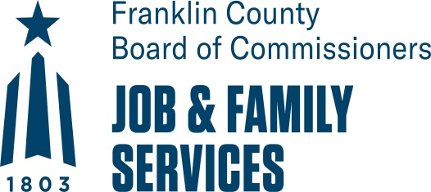

Youth Enrichment Program Resource Fair Registration Form

Franklin County Job and Family Services (FCDJFS) seeks organizations to work with our Innovative Out-of-School Time Youth providers to offer youth enrichment programming or activities during summer learning and afterschool programs. Enrichment experiences include: STEAM (Science, Technology, Engineering, Art, and Math), Artistic Expression, Nutrition, Cultural, Social/Emotional and other creative programming and services. To register for the resource fair complete the information below and email the form to FCDJFS at dssrfp@fcdjfs.franklincountyohio.gov by Wednesday, March 6th at 2:00 PM.

Date

Business/Agency Name

Phone Number

FEIN # if applicable

Director/Owner

Business Address

Mailing Address

How many years in business? 2 years or less 3 – 5 years over 5 years

E-Mail Address

How many employees do you have? 1 – 2 3– 5 Over 5

Services Provide: Please include a description of the services provided below and attach any marketing/business materials.

Have you or any member of your staff (team) ever been convicted of a criminal offense? Yes [ ] No [ ] If yes, please explain

Please list past or current professional references

- Organization

Name & Title Phone Email

Address (Street, City, State, Zip)
2. Organization

Name & Title Phone Email

Address (Street, City, State, Zip)
3. Organization

Name & Title Phone Email

Address (Street, City, State, Zip)

Please Note: Employees of your organization will be required to successfully pass a criminal background check prior to providing services to a FCDJFS funded Out-of-School Time Youth Program.

Print Name: Title:

Signature: Date:

Please attach any marketing material or other information which will provide further insight into your program and services.

